DESIGNING A NATIONAL CLIMATE SMART LOCAL CHICKEN BREEDING PROGRAM FOR LAO PDR
Phannika Khoutsavang¹, Christian Keambou Tiambo², Yao Nasser³

¹National Agriculture and Forestry Research Institute (NAFRI), Vientiane 01170, Lao PDR
²Centre for Tropical Livestock Genetics and Health (CTLGH)-ILRI, Nairobi, Kenya
³Biosciences Eastern and Central Africa - International Livestock Research Institute (BecA-ILRI) Hub, P.O. Box 30709, Nairobi, Kenya

Introduction
The Lao People's Democratic Republic (Lao PDR) exhibits high genetic diversity in local chicken populations, which are widely distributed across the country's agro-ecological zones. The poultry sector in Laos has expanded steadily over time. The reports estimated that the total poultry population was around 21 million birds, consisting mainly of chickens and ducks, while geese, turkeys, and pigeons accounted for only a small proportion. In recent years, the poultry population has increased to approximately 36.9 million birds, and projections suggest it could reach approximately 50.1 million by 2022 (Ministry of Agriculture and Forestry, 2022). By 2025, the poultry population is expected to grow further to around 57 million birds, reflecting the increasing demand for poultry meat in the country.
Local chickens are crucial for rural livelihoods and food systems in many developing countries. In Lao PDR, smallholder farmers widely raise them for household nutrition, income, and socio-cultural purposes. Local chickens are well adapted to harsh environments, disease challenges, and low-input systems, making them valuable genetic resources (Guèye, 2000; Dana et al., 2010; FAO, 2015). They provide essential protein and support economic development, especially in remote areas with limited access to commercial livestock (Bouahom et al., 2007; FAO, 2015). However, productivity remains low due to traditional production systems, limited genetic improvement, and increasing challenges from climate change (Birhanu et al., 2021; Macharia et al., 2022). A major factor contributing to this situation is the absence of a coordinated national breeding strategy and systematic programs for performance recording and genetic evaluation. Without such frameworks, achieving sustainable genetic improvement while maintaining adaptive traits such as disease resistance and environmental tolerance is difficult (Dana et al., 2010; FAO, 2015). These challenges highlight the urgent need to develop a coordinated, climate-smart breeding program for local chickens in Lao PDR, aimed at improving productivity, conserving valuable genetic resources, and enhancing resilience to environmental and disease-related stresses while supporting rural livelihoods.
Therefore, developing a national climate-smart breeding program for local chickens in Lao PDR presents an opportunity to enhance productivity and resilience, with a focus on conserving and strategically utilizing indigenous genetic resources. Integrating performance recording, genetic evaluation, and farmer participation can support long-term genetic improvement, improve food security, and strengthen rural livelihoods.

Research Gap

Despite the recognized importance of indigenous chickens for rural livelihoods and food security in Lao PDR, significant gaps remain in the design and implementation of breeding programs. Existing approaches largely lack an integrated framework that simultaneously addresses climate-smart practices, productivity improvement, inclusivity of smallholder farmers, and conservation of genetic biodiversity. Moreover, there is limited evidence linking genetic improvement of local chicken populations to tangible outcomes in production, climate resilience, and household livelihoods. Addressing these gaps is critical for developing a comprehensive, sustainable, and context-specific breeding strategy that can enhance both the productivity and resilience of smallholder poultry systems.
Breeding goals
The breeding program is designed to strengthen climate resilience, enhance productivity, support inclusive participation, and conserve local biodiversity. It will focus on improving key traits such as heat tolerance, disease resistance, feed efficiency, and performance in both egg and meat production, while ensuring high survival rates. Particular emphasis will be placed on involving women, youth, and smallholder farmers in all stages of the program. At the same time, indigenous chicken ecotypes will be carefully maintained to safeguard genetic diversity. Measurable targets will guide implementation and monitor progress.
Breeding objectives
The overall objective of this breeding program is to develop and implement a national climate-smart breeding strategy for local chickens in Lao PDR. The specific objectives are to improve adaptive, productive, and fitness traits, while conserving the genetic resources of local chickens.
Overview of a typical breeding program is presented using a schematic representation of seven key steps.
The overall process of a breeding program involves a series of systematic steps that collectively aim to achieve the long-term genetic improvement of an animal population. A schematic representation of these steps is shown in Figure 1. Typically, the program is depicted as a cyclical process comprising seven key steps (Hutu et al, 2025), as follows:
- Description of the production system: Understanding the environmental conditions, management practices, and socio-economic context is essential to ensure that breeding objectives are practical and achievable.
- Defining the breeding goal: The breeding objectives are determined based on traits of economic, adaptive, and social importance.
- Data collection: Phenotypic and genotypic information, including pedigree and genetic relationships, is gathered to provide a foundation for selection.
- Estimation of breeding values: Statistical methods are used to predict the genetic potential of animals for the traits of interest.
- Selection and mating: Superior animals are chosen for reproduction, and mating plans are designed to optimize genetic gain while maintaining genetic diversity.
- Dissemination of genetic gains: Genetic improvement is propagated throughout the population via selected breeding animals or reproductive technologies.
- Evaluation of genetic progress and diversity: Outcomes are assessed, including improvements in target traits and maintenance of genetic variation. This evaluation informs the next cycle of the breeding program.
The seven-step breeding framework described above provides a systematic foundation for the design and implementation of sustainable genetic improvement programs. In the context of designing a national climate-smart local chicken breeding program for Lao PDR, this framework serves as a strategic guide to ensure that genetic improvement aligns with the country’s environmental conditions, production systems, and socio-economic realities. Therefore, applying this cyclical breeding approach provides a scientifically grounded pathway for enhancing productivity, resilience to climate change, and long-term sustainability of local chicken genetic resources in Lao PDR.
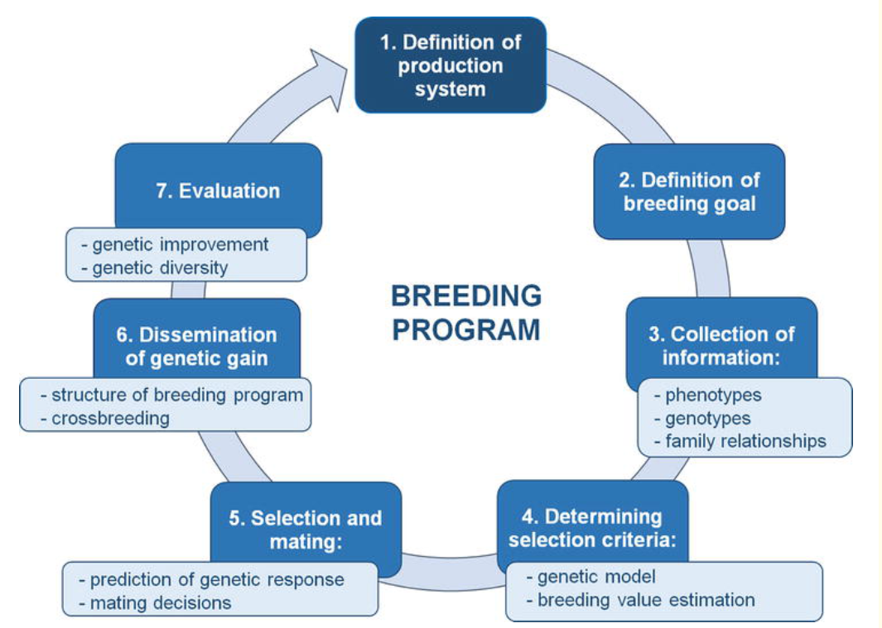
Figure 1. Seven-Step Process of a Typical Breeding Program (Hutu et al, 2025).

Overview of Local chicken breeds in Lao PDR
Identification of Local Chicken Breeds in Lao PDR
Previous studies by Bouanhom et al. (2007) and the Food and Agriculture Organization (FAO) classified indigenous chickens from highland and lowland production systems into five phenotypically distinct breeds: Ou, Black Bone, Yolk, Chae, and Horn Chou, as shown in Figure 2. Each of these indigenous breeds exhibits unique characteristics that contribute significantly to household food security and income generation, thereby supporting rural livelihoods and overall community well-being.
The Ou chickens, the largest indigenous chicken type in Lao PDR, is primarily raised in Hmong communities in Luang Prabang Province. Adult males have an average body weight of approximately 2.7 kg, whereas females weigh around 1.6 kg. Phenotypically, the breed is characterized by mostly black plumage, with red feathers observed on the wings and neck region. Despite its relatively large body size, the Ou breed exhibits comparatively low reproductive performance, producing an average of 55 eggs per hen per year, with a hatchability rate of approximately 67%.
The Yolk chickens are traditionally selected for cockfighting purposes. It is widely raised in Champasak and Savannakhet provinces, where farmers favor Kai Yolk chickens for their relatively large body size, efficient feed utilization, and adaptability to lowland production environments. Adult males typically weigh between 1.5 and 1.8 kg, whereas females range from 1.3 to 1.5 kg. In terms of reproductive performance, hens produce an average of 56 eggs per year, with an approximate hatchability rate of 70%.
Chae chickens are small-bodied and widely distributed across production areas, and they are particularly recognized for their diverse and colorful plumage patterns. Two main varieties are distinguished based on wattle coloration: the white-wattled type and the red-wattled type. Adult females typically weigh between 0.8 and 0.9 kg, whereas adult males generally weigh less than 1.0 kg. This breed is well adapted to local production conditions and is relatively easy to manage under smallholder systems. In terms of reproductive performance, hens produce approximately 78 eggs per year, with a hatchability rate of around 80%, and they exhibit strong maternal behavior.
Horn Chou chickens are phenotypically similar to the Chae breed; however, they are distinguished by the presence of a pea comb and a relatively larger body size. Adult females typically weigh between 1.2 and 1.5 kg, whereas adult males range from 1.3 to 1.7 kg. In terms of reproductive performance, hens produce an average of approximately 70 eggs per year, with a hatchability rate of about 75%.
Black Bone chickens, originally from China, are predominantly raised in Luang Prabang and Oudomxay provinces. This genetic group comprises two distinct varieties. The first is characterized by a relatively small body size, with black skin and flesh accompanied by white plumage. The second variety exhibits dark brown to black plumage and has a comparatively larger body size. At sexual maturity, males typically weigh between 2.0 and 2.3 kg, whereas females weigh approximately 1.5 kg. Hens produce an average of 76 eggs per year, with a hatchability rate of around 80%.

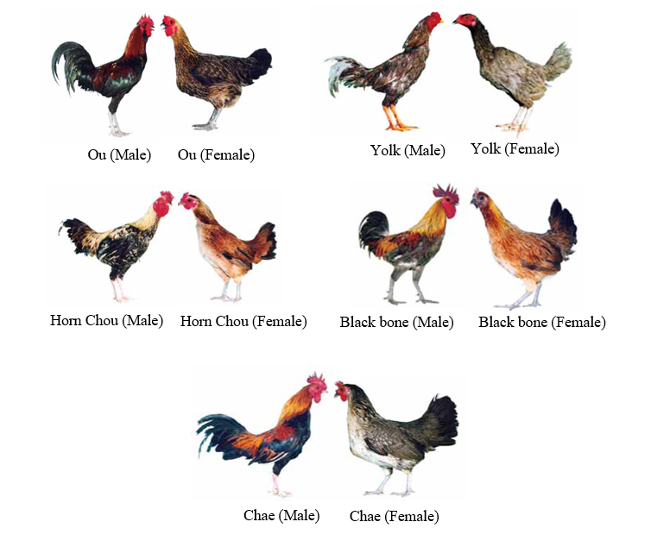
Figure 2. Based on phenotypic characterization, five indigenous chicken types were identified and differentiated (Bouahom et al., 2007).
Furthermore, previous studies have classified indigenous chicken breeds using nucleotide based functional group analysis of genomic DNA. Principal component analysis (PCA) revealed four distinct genetic clusters—Yolk, Chae, Black Bone, and Ou—with partial overlap observed for Horn Chou (Khoutsavang., 2024.Thesis), as shown in Figure 3.
In addition, a previous study conducted under the Project Collaboration between Thailand and Lao PDR for the Conservation and Development of indigenous Chickens in the Lao PDR (2020) reported the presence of chickens that could not be assigned to any specific breed category, as shown in Figure 4.
Although previous studies have phenotypically identified five local chicken breeds in Lao PDR, significant gaps remain in genetic validation, breed standardization, and population structure characterization. These limitations constrain the development of a scientifically robust and climate-smart national breeding program.
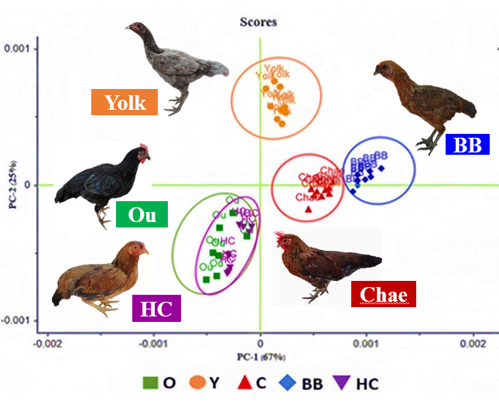
Figure 3. Genetic Clustering of Indigenous Chicken Breeds Based on PCA (Khoutsavang., 2024.Thesis).
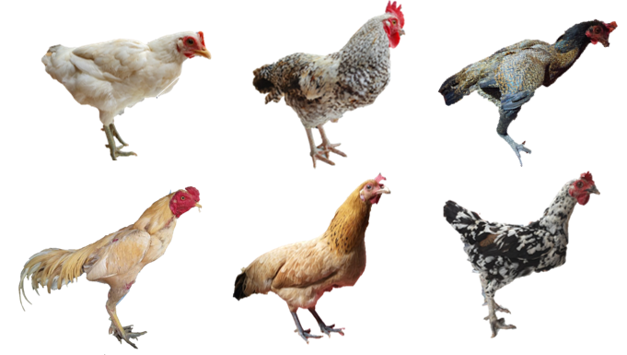
Figure 4. Indigenous chickens that could not be assigned to a specific breed category based on the 2020 Thailand–Lao PDR conservation and development project https://digital.library.tu.ac.th/tu_dc/frontend/Info /item/dc:173407
Description of the Chicken Production System in Lao PDR
Poultry Production Systems in Lao PDR
According to Burgos et al. (2008), poultry production in Lao PDR is dominated by three main systems: extensive, semi-intensive, and intensive. The extensive production system is the most widespread, characterized by small household flocks. Poultry in this system are raised under a scavenging approach, foraging freely around the household during the day and roosting at night in trees, under houses, or in simple natural shelters. This low-input system allows households to maintain poultry with minimal resources and management.
The semi-intensive production system represents an intermediate approach, where birds are allowed to scavenge during the day but are confined in enclosures at night to protect them from predators. This system provides a balance between natural foraging and protection, contributing to improved survival rates compared to extensive systems.
The intensive production system relies on improved breeds of layers and broilers, often imported from Thailand. Flock sizes in intensive systems typically range from 1,000 to 5,000 birds per farm. Birds are managed under controlled feeding and housing conditions to maximize productivity and efficiency.
Overall, the extensive system is the dominant form of poultry production in Lao PDR, accounting for approximately 84% of flocks, while semi-intensive and intensive systems represent 11% and 5%, respectively (Burgos et al., 2008), as shown in Figure 5. The strong presence of extensive poultry systems highlights their key role in supporting rural livelihoods, whereas the increasing adoption of semi-intensive and intensive systems points to opportunities for improving overall productivity in Lao PDR.
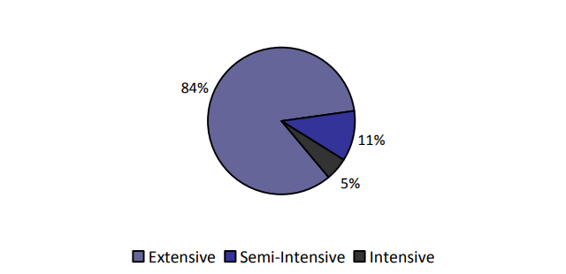
Figure 5. Distribution of poultry production systems in Lao PDR. The extensive system dominates with 84% of flocks, followed by semi-intensive (11%) and intensive (5%) systems (Burgos et al., 2008).
Purpose of Raising Local Chickens
Local chickens in Lao PDR are primarily raised to support household food consumption and to provide additional income for rural families. Eggs and meat from Local chickens contribute directly to daily nutrition, while surplus chickens are commonly sold in local markets to generate cash for household expenses. This small-scale poultry production is particularly important for low-income households because it requires minimal investment and can be managed under extensive scavenging systems. In addition to their economic and nutritional value, local chickens also play important social and cultural roles. They are commonly used in traditional ceremonies, such as baci ceremonies and spirit worship (https://digital.library.tu.ac.th/tu_dc/frontend/Info/item/dc:173407). Furthermore, some Local chickens are raised for sporting purposes, especially cockfighting, which remains a traditional activity in rural communities (Livestock Research Center, 2014). These multiple roles demonstrate that local chickens are not only a source of food and income but also an important component of rural livelihoods and cultural traditions in the Lao PDR.
Local Chicken Production Systems in Lao PDR
Local chicken production in Lao PDR is predominantly based on traditional village systems, which can be broadly classified into extensive and semi-intensive production systems (Figure 6). The extensive system is the most common and is practiced in the majority of rural villages, where chickens are allowed to roam freely during the day in search of feed, relying mainly on natural scavenging resources such as insects, seeds, household scraps, and crop residues. Under this system, housing is generally not provided, and birds typically roost at night in trees, under houses, or in simple natural shelters that offer protection from predators and adverse weather (https://digital.library.tu.ac.th/tu_dc/frontend/Info/item/dc:173407).
In contrast, the semi-intensive production system involves a slightly higher level of management. Chickens are allowed to scavenge freely during the daytime but are confined in enclosures during the night. Housing in this system is usually simple and constructed from locally available materials such as bamboo, with palm-thatch or rice-straw roofing. In many households, chickens and ducks are often kept together in the same shelter (Figure 7). This system provides better protection against predators and improves flock management while still maintaining low input costs suitable for smallholder farmers (Livestock Research Center, 2014). These production systems reflect the adaptation of local chicken production to the socio-economic conditions, resource availability, and traditional management practices of rural households in Lao PDR.
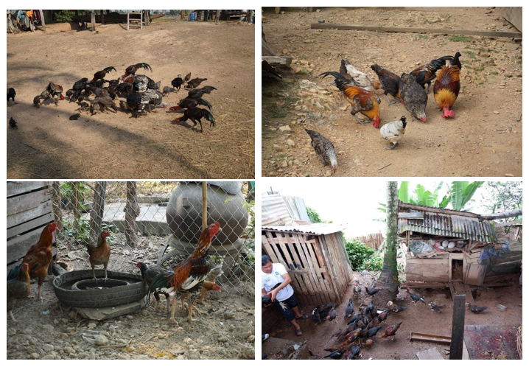
Figure 6. Local chicken production systems in Lao PDR: extensive free-range and semi-intensive systems (Phot credit: Khoutsavang. P).
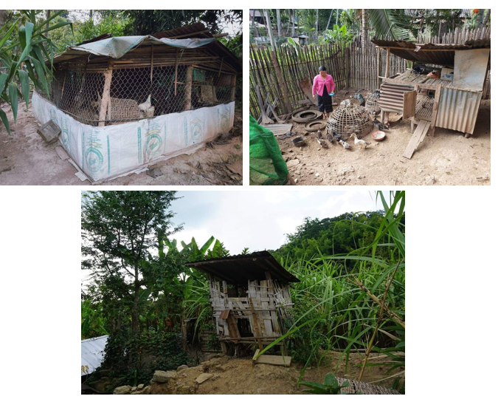
Figure 7. Housing of local chickens in a semi-intensive production system in Lao PDR (Phot credit: Khoutsavang).
Feeding and Water Management in Local Chicken Production in Lao PDR
Local chickens in Lao PDR are primarily raised under low-input production systems, where feeding relies heavily on natural scavenging resources. In the extensive free-range system, chickens forage freely around households and village areas, consuming insects, worms, seeds, crop residues, and household leftovers. In semi-intensive systems, farmers provide supplementary feed 1–2 times daily, typically in the morning and afternoon, to encourage chickens to return home and reduce predation risk (Phommasack et al., 2014; Livestock Research Center., 2014).
Supplementary feed commonly includes locally available resources such as rice bran, maize, cassava, broken rice, paddy rice, vegetable residues, and household food leftovers. Some households also use commercial feed, although the high cost limits widespread adoption. Energy is mainly derived from paddy rice, broken rice, rice bran, maize, and cassava, while protein comes from scavenged insects, worms, and household by-products. Green feeds, such as vegetable residues and other plant materials, are largely obtained from local sources and scavenging (Phommasack et al., 2014; https://digital.library.tu.ac.th/tu_dc/frontend/Info /item/dc:173407).
Water provision varies with production system and season. In extensive systems, chickens access water from wells, pipes, canals, or other natural sources. In semi-intensive systems, farmers may provide additional water in containers. During the dry season, natural water sources become scarce, leading to water shortages that can negatively impact chicken health, feed intake, and overall productivity (https://digital.library.tu.ac.th/tu_dc/frontend/Info /item/dc:173407). Although local chickens primarily rely on scavenging and household feed resources, quantitative information on nutrient intake, seasonal feed variability, and water availability is limited. Moreover, breed-specific nutritional efficiency and adaptation under low-input production systems remain poorly understood. These gaps are critical to inform the design of a climate-smart breeding program that aligns with real production conditions.
Mating system of local chicken in Lao PDR
Local chickens in Lao PDR are predominantly raised under a random mating system, where mating occurs naturally with minimal control over parent selection. In most villages, all chicken breeds are raised together, allowing birds of different breeds to mate freely without any form of controlled breeding or planned selection (https://digital.library.tu.ac.th/tu _dc/ /frontend/Info/item/dc:173407). Consequently, no controlled mating, planned breeding program, or pedigree records are maintained at the household or village level.
Key characteristics of the mating system include:
- Uncontrolled male-to-female ratios, which may increase the risk of inbreeding.
- Absence of pedigree and mating records limits opportunities for genetic evaluation, selection, and systematic improvement.
- No structured breeding programs, meaning that breed improvement and conservation rely entirely on natural mating.
The lack of structured or planned breeding programs at the village level represents a major constraint for the sustainable conservation and genetic improvement of local chickens in Lao PDR. Understanding and addressing these gaps is crucial for designing climate-smart and locally adapted breeding strategies that ensure the maintenance of genetic diversity while improving productivity under low-input systems.
Environmental condition
Local chickens in Lao PDR are raised under tropical environmental conditions characterized by high temperatures, high humidity, and distinct rainy and dry seasons. Most production occurs in predominantly rural areas with limited housing and minimal environmental control, exposing chickens to natural climatic fluctuations (Bouahom et al., 2007; Livestock Research Center., 2014).
In additional, Bouahom et al. (2007) reported that local chickens in Lao PDR are managed across two ecologically distinct zones. The lowland tropical humid deciduous forest zone is predominantly located along the Mekong corridor, where rice cultivation dominates during the rainy season. Farmers commonly practice integrated crop–livestock systems, in which chickens feed mainly on agricultural by-products such as rice bran and broken rice. In contrast, the highland tropical dry forest zone is found in the mountainous northern regions, where poor infrastructure, rugged terrain, and low soil fertility limit intensive agricultural practices. As a result of these environmental constraints, livestock productivity, including that of local chickens, is generally lower in these areas. Despite the importance of environmental conditions in shaping production systems, there is limited information on how high temperature, humidity, and seasonal variation affect the performance and adaptive capacity of local chickens. In addition, the effects of crop–livestock integration in lowland systems and environmental constraints in highland areas on chicken productivity and adaptation remain poorly understood. These knowledge gaps limit the development of climate-smart and environment-specific breeding strategies that are appropriate for local production conditions in Lao PDR.
Health management
Local chickens in Lao PDR are commonly raised under traditional village conditions, where health management practices are limited and disease remains a major constraint to productivity. Infectious diseases, particularly Newcastle disease and avian influenza, are the primary causes of high mortality in village flocks. These diseases are often identified based on observable clinical signs, as laboratory confirmation is rarely available in rural areas (Bouahom et al., 2007). In addition, disease prevention relies mainly on occasional vaccination campaigns, which often have limited coverage and irregular implementation, especially in remote villages.
Access to veterinary services and animal health support is also restricted. Diagnostic investigations during disease outbreaks are insufficient, and most farmers depend on their own experience to manage sick birds. Basic disease control measures, such as isolating sick chickens and maintaining cleanliness in poultry housing areas, are sometimes practiced at the household level and play an important role in reducing disease transmission. However, these practices are not consistently applied across communities (Alders, 2004; Wilson, 2008). Furthermore, natural disasters, including seasonal flooding and climate variability, contribute to additional flock losses and increase the vulnerability of smallholder production systems (Bouahom et al., 2007). Although local chickens play a crucial role in supporting rural livelihoods, significant gaps persist in their health management. The incidence and impact of major infectious diseases are poorly documented, and vaccination programs do not provide adequate coverage. Limited veterinary services, lack of diagnostic capacity, and the absence of systematic surveillance and biosecurity measures constrain effective disease control. These limitations hinder sustainable genetic improvement and the development of climate-resilient and productive local chicken populations in Lao PDR.
Determining the purpose of the chicken within the system
Local chickens in Lao PDR are multi-purpose and highly adaptable, serving diverse roles in rural livelihoods. Their function within the production system can be categorized into three main objectives: food security, income generation, and cultural or recreational uses.
- Food Security (Eggs and Meat) Chickens provide a direct source of animal protein for household consumption. Maintaining breed diversity through the selection of local ecotypes—such as Ou, Yolk, Black Bone, Horn Chou, and Chae—ensures adaptability to low-input systems while supporting consistent egg and meat production.
- Income Generation (Sale of Chicken and Eggs) Farmers rely on chickens as a source of supplementary income, selling eggs and meat within local markets. Productivity improvement, measured by parameters such as growth rate, egg production, and meat yield, is a key driver for enhancing household income while sustaining local breeds.
- Cultural and Recreational Use Chickens also serve social and cultural purposes, including participation in traditional games, fighting events, and local rituals. This function contributes to the maintenance of genetic diversity, as different local breeds are preserved and valued for cultural traits beyond productivity.
These three primary objectives intersect with broader production considerations, particularly:
- Disease Resistance and Low-Input Adaptation: Local chickens are often raised under minimal-input systems and are exposed to various infectious diseases. Their inherent resilience and adaptability are crucial for ensuring survival and productivity under such conditions.
- Climate Resilience and Suitability to Local Systems: The ability of local chickens to adapt to variable climatic conditions and environmental challenges ensures their sustainable integration into low-resource farming systems.
Thus, the purpose of the breeding program design is to integrate these objectives, providing a framework for climate-smart and locally adapted breeding programs. The ultimate goals of such programs are to:
- Enhance productivity (egg and meat output, growth rate);
- Maintain genetic diversity among local breeds; and
- Improve adaptability and disease resistance, ensuring resilience under low-input and variable environmental conditions.
This structured approach allows breeding strategies to align with both household livelihood goals and conservation of locally adapted genetic resources, ensuring sustainability and long-term benefits for rural communities (Figure 8).
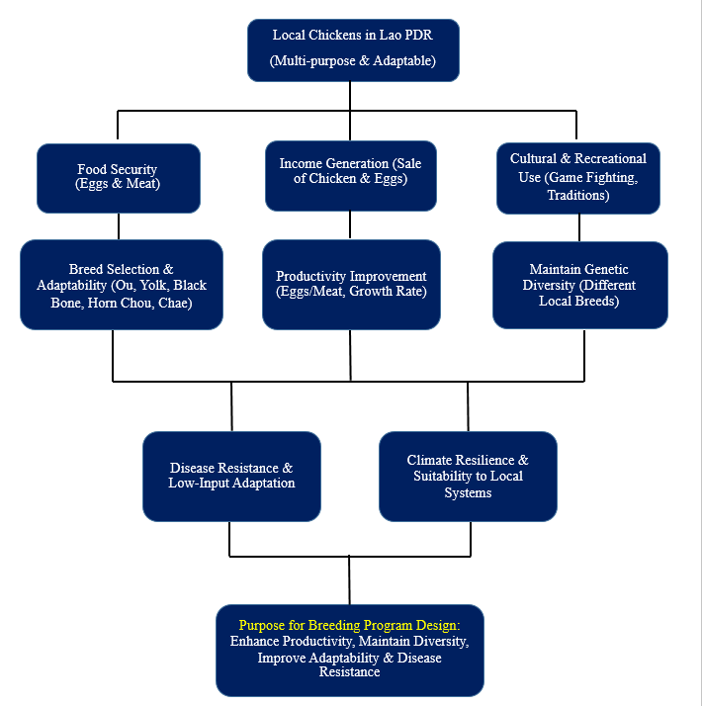
Figure 8. Flowchart of the objectives and breeding targets for designing a climate-smart, and
locally adapted breeding program for local chickens in Lao PDR.
Alignment with National Policy and Strategic Development Vision
Lao PDR has prioritized sustainable economic transformation, rural poverty reduction, and resilience building as central components of its national development agenda, particularly in advancing toward graduation from Least Developed Country (LDC) status. National policies focus on modernizing agriculture, strengthen national food security, and promoting inclusive rural development, while enhancing adaptive capacity in vulnerable rural systems remains critical in the face of climate variability and environmental pressures (Lao PDR, 2021). Concurrently, Lao PDR advances biodiversity conservation and climate adaptation through the National Biodiversity Strategy and Action Plan (NBSAP), the Nationally Determined Contribution (NDC), and the National Adaptation Plan (NAP), emphasizing the conservation of indigenous genetic resources and the integration of climate-resilient agricultural practices (Ministry of Natural Resources and Environment, 2016; Ministry of Natural Resources and Environment, 2020). Nevertheless, despite these broad policy goals, there remains a lack of targeted strategies to integrate climate-smart approaches into specific agricultural sectors, such as local chicken production, which limits the ability to fully strengthen resilience and sustainable livelihoods in rural communities.
In this context, smallholder poultry production plays a vital role in supporting livelihoods, providing affordable protein, and preserving locally adapted genetic resources. Targeted breeding programs for indigenous chickens can simultaneously improve productivity, strengthen resilience to climate- and market-related shocks, and contribute to economic growth and food security. By integrating genetic resource conservation, productivity enhancement, and climate-smart strategies, the development of locally adapted poultry directly supports national priorities and long-term rural development (Ministry of Agriculture and Forestry, 2015; Lao PDR, 2021). However, actionable frameworks for integrating climate-smart breeding with local chicken production remain underdeveloped, representing a key gap for supporting rural livelihoods and policy implementation.
The National Strategy on Climate Change of Lao PDR emphasizes the need to integrate climate adaptation and mitigation measures across agricultural sectors, recognizing that livestock systems are both vulnerable to climate change and contributors to it (Ministry of Natural Resources and Environment, 2010). Strengthening locally adapted chicken breeds through climate-informed breeding objectives directly supports these national strategies by enhancing resilience, disease resistance, and the capacity to perform under challenging environmental conditions. By aligning genetic improvement with climate-smart objectives, such programs can achieve both immediate productivity gains and long-term environmental sustainability.

At the global level, this this national breeding initiative supports the Sustainable Development Goals (SDGs), particularly SDG 1 (No Poverty), SDG 2 (Zero Hunger), SDG 5 (Gender Equality ), SDG 12 (Responsible Consumption and Production), SDG 13 (Climate Action), and SDG 17 (Partnership for the Goals) (http://www.un.org/ sustainabledevelopment/sustainable-development-goals/, January 15, 2017). By combining efforts to enhance productivity with the conservation of genetic resources and the promotion of climate resilience, the proposed National Climate-Smart Local Chicken Breeding Program in Lao PDR contributes not only to national development objectives but also to broader international sustainability commitments.

Role of Smallholder Poultry Production

Smallholder poultry production plays a vital role in rural livelihoods and food systems in Lao PDR. Indigenous chickens, typically raised under low-input scavenging or semi-scavenging systems, provide a regular source of animal protein and generate supplementary income for resource-poor households (FAO, 2014). These locally adapted birds are tolerant to heat, resistant to endemic diseases, and able to thrive under limited feed, making their conservation critical for maintaining genetic diversity and long-term production sustainability (FAO, 2015; Mwacharo et al., 2013). Poultry keeping, often managed by women and youth, also promotes income generation, empowerment, and inclusive rural development (Alders and Pym, 2009). Strengthening indigenous chicken production thus contributes simultaneously to food security, rural income diversification, genetic resource conservation, and inclusive agricultural development.
Agro-Ecological Zones and Ecotypes
Local chickens in Lao PDR are distributed across different agro-ecological zones, including lowland, upland, and mountainous regions. These environments have contributed to the development of distinct local chicken phenotypes that are well adapted to local production systems and traditional rearing practices. Surveys of village poultry systems have shown that native chickens are raised throughout rural Lao PDR under extensive and semi-extensive systems, reflecting their adaptation to local agro-ecological conditions and farmers’ management strategies (Bouahom et al., 2007; Ministry of Agriculture and Forestry, 2017). Moreover, previous studies by Bouanhom et al. (2007) and the Food and Agriculture Organization classified indigenous chickens from highland and lowland production systems into five phenotypically distinct breeds: Ou, Black Bone, Yolk, Chae, and Horn Chou. Local chickens in Lao PDR encompass several locally recognized ecotypes, each associated with specific geographical and agro-ecological zones (Table 1).
Ou chickens are predominantly found in upland Hmong villages in Luang Prabang, where cooler conditions and traditional mountain agriculture prevail. Yolk chickens are common in lowland provinces such as Champassak and Savannakhet, where they are adapted to warmer floodplain environments and widely scavenge in rice-growing landscapes. Chae chickens are widely distributed throughout Lao PDR and are characterized by their small body size and diverse plumage color variations, reflecting their adaptation to a wide range of village agro-ecological environments. Black Bone chickens are mainly present in northern areas such as Luang Prabang and Oudomxay and are culturally valued for traditional cuisine. Horn Chou chickens occur across diverse agro-ecological zones and show high flexibility in coping with varied environmental conditions. These ecotypes reflect the strong influence of geography, traditional management systems, and farmer preferences on the distribution and adaptation of indigenous chickens in Lao PDR.
Table 1. Summary of local chicken ecotypes and their agro-ecological zones in Lao PDR
Ecotype  (Local Name) | Typical Location in Lao PDR | Agro-ecological Zone / Notes
Ou | Luang Prabang, Hmong villages (North) | Upland / Highland zones — adapted to higher elevation areas with cooler temperatures and traditional upland farming systems.
Yolk | Champassack, Savannakhet (South) | Lowland riverine and floodplain zones — suited to warmer lowland conditions with abundant scavenging resources.
Chae | Widely distributed throughout Laos | General village environments — small body size, well-adapted to varied local conditions including upland and lowland areas.
Black Bone Chicken | Luang Prabang, Oudomxay (North) and other rural areas | Upland / Mid-altitude zones — valued for cultural use (e.g., soups), known for adaptation to local climates and scavenging.
Horn Chou | Widely distributed | Scattered across lowland, upland, and plateau zones — generalist ecotype highly adaptable to many agro-ecological situations.

Phenotypic Characteristics
The phenotypic characteristics of Local chicken ecotypes in Lao PDR show substantial variation in body weight and egg production traits, reflecting their adaptation to diverse agro-ecological environments and traditional village production systems. Previous studies by Bouahom et al. (2007) and the Food and Agriculture Organization (FAO) reported that the Ou chicken is the largest ecotype, with average body weights of approximately 2.7 kg in males and 1.6 kg in females. However, this ecotype exhibits relatively low egg production, averaging about 55 eggs per hen per year, and a hatchability rate of approximately 67%. The Yolk chicken is characterized by an intermediate body weight, ranging from 1.5 to 1.8 kg in males and 1.3 to 1.5 kg in females, and produces approximately 56 eggs per hen per year, with a hatchability rate of about 70%. This ecotype is well adapted to lowland production systems and is commonly maintained under scavenging conditions. In contrast, the Chae chicken is the smallest ecotype, with males weighing less than 1.0 kg and females ranging from 0.8 to 0.9 kg. Despite its small body size, the Chae chicken shows the highest egg production, averaging 78 eggs per hen per year, and the highest hatchability rate of approximately 80%. This finding suggests that smaller indigenous chickens tend to have better reproductive performance, which is advantageous under low-input village conditions. The Black Bone chicken exhibits moderate body weight, ranging from 1.3 to 1.7 kg in males and 1.2 to 1.5 kg in females, with an average egg production of about 70 eggs per hen per year and a hatchability rate of approximately 75%. Similarly, the Horn Chou chicken shows a relatively large body size, with males weighing between 2.0 and 2.3 kg and females around 1.5 kg, and demonstrates high egg production of approximately 76 eggs per hen per year, with a hatchability rate of about 80%. These differences among ecotypes highlight the influence of genetic background, farmer selection, and environmental adaptation on phenotypic performance traits, as shown in Table 2.
Overall, the results confirm that Local chickens in Lao PDR possess diverse phenotypic characteristics, with clear variation in growth and reproductive performance. This diversity represents an important genetic resource for sustainable breeding and conservation programs under village production systems.

Table 2. Phenotypic performance of local chicken ecotypes in Lao PDR
Ecotype | Body weight (kg) |  | Egg production |  | Hatchability rate (%) | Survival rate (%)
 | Male | Female | Egg number  (egg/hen/year) | Egg weight  (g)
Ou | 2.7 | 1.6 | 55 | - | 67 | -
Yolk | 1.5–1.8 | 1.3–1.5 | 56 | - | 70 | -
Chae | <1.0 | 0.8–0.9 | 78 | - | 80 | -
Black Bone | 1.3–1.7 | 1.2–1.5 | 70 | - | 75 | -
Horn Chou | 2.0–2.3 | 1.5 | 76 | - | 80 | -

Adaptive and Behavioral Traits
Local chickens in Lao PDR possess several adaptive and behavioural characteristics that enable them to survive and reproduce efficiently under traditional village production systems. These traits have developed through long-term natural and farmer selection within diverse agro-ecological zones. One important characteristic is brooding behaviour. Local hens show strong maternal instinct and natural incubation ability, which allows farmers to rely on natural reproduction without artificial hatchery systems (FAO, 2019). In addition, local chickens demonstrate excellent scavenging ability, enabling them to utilize locally available feed resources such as insects, crop residues, and household waste (Kawabe et al., 2014). This reduces feed costs and supports low-input production systems. Local chickens are also known for their relatively higher disease resistance compared to exotic breeds, particularly under village conditions where biosecurity is limited (Maw et al., 2015). Furthermore, they exhibit strong heat tolerance, allowing them to maintain survival and basic productivity under tropical climatic conditions typical of Lao PDR (FAO, 2019). These adaptive traits contribute significantly to rural livelihoods and food security, particularly among smallholder farmers in upland and lowland areas. However, there is no published information on the adaptive traits, including brooding ability, scavenging ability, disease resistance, and heat tolerance, of native chicken ecotypes in Lao PDR. These traits vary among ecotypes, but direct evidence for Lao populations is lacking.

Socio-Economic and Cultural Importance

Farmer selection criteria

In Lao PDR, local chickens are primarily raised under smallholder village production systems, where farmers apply traditional selection criteria based on production performance, adaptability, and household needs. Body size is one of the most important traits, as larger birds provide higher meat yield and greater market value (Melesse, 2014). Egg production is another key selection criterion, particularly for ensuring household food security and supporting natural reproduction through brooding (FAO, 2014). In addition, disease resistance and survival ability are highly valued traits, as indigenous chickens are typically raised in low-input scavenging systems with limited veterinary care (Wong et al., 2017). Furthermore, a previous study conducted under the Project Collaboration between Thailand and Lao PDR for the Conservation and Development of Indigenous Chickens in Lao PDR (2020) reported that farmers in Luang Prabang Province kept some chickens for breeding purposes without clear selection criteria. In Phongsali Province, farmers selected chickens for breeding based on external characteristics and behaviour. For females, selection focused on high egg production, good hatchability, and strong maternal ability. For males, large body size and attractive plumage were the main selection criteria. Similarly, farmers in Savannakhet Province also selected chickens for breeding purposes based on preferred production and phenotypic traits (https://digital.library.tu.ac.th/tu_dc/frontend/Info/item/dc:173407). However, despite the importance of these farmer-preferred traits, systematic information on how these selection practices influence the genetic diversity and population structure of indigenous chickens in Lao PDR remains limited. Therefore, a better understanding of the relationship between farmer selection criteria and genetic characteristics is essential for developing effective conservation and sustainable breeding programs.

Gender roles
Gender roles are an important component of indigenous chicken production systems in Lao PDR, particularly within smallholder village conditions where family poultry contributes to household nutrition, income, and social functions. Women are primarily responsible for routine management activities, especially those related to egg production. Their responsibilities include feeding, providing water, egg collection, caring for brooding hens, and rearing chicks. Eggs represent an accessible source of animal protein for household consumption and are also sold in local markets, allowing women to generate small but regular income and contribute directly to household financial security (Alders, 2004; Lormaisim et al., 2023). These responsibilities highlight the central role of women in maintaining flock productivity and improving family nutrition. In contrast, men dominate activities involved in activities related to meat production, particularly decision-making on the sale, slaughter, selection of birds for consumption or marketing, and building houses for them (Lormaisim et al., 2023). Local chickens raised for meat often have higher economic value, and larger birds are preferred for traditional ceremonies, religious events, and social obligations in Lao communities. Consequently, men tend to influence selection decisions toward traits such as body size and growth performance, which are directly linked to meat yield and market price.
This gender-based division of labor reflects both economic and cultural structures within rural households. Women play a key role in maintaining flock size and reproduction, while men focus on income generation and socio-cultural functions. Recognizing these gender roles is therefore essential for designing sustainable breeding programs and conservation strategies for indigenous chickens in Lao PDR, as women are the primary custodians of local chicken genetic resources. Understanding these dynamics allows interventions to conserve valuable traditional knowledge while improving management practices and productivity.

Cultural importance
Local chickens in Lao PDR have important cultural roles in rural communities, where they are closely associated with traditional beliefs, rituals, and social practices. Chickens are commonly used in religious ceremonies, ancestor worship, and traditional healing rituals, where specific physical characteristics such as plumage color or body condition may be preferred depending on the cultural purpose. These practices reflect the symbolic value of local chickens and their role in maintaining cultural identity and continuity within ethnic communities (Alders, 2004; Bouahom et al., 2007). In addition, Local chickens are frequently used in social events such as weddings, festivals, and community gatherings, where they contribute to strengthening social relationships and cultural cohesion. The maintenance of local chicken populations is therefore not only important for household food security and income but also for preserving cultural heritage and traditional knowledge related to animal selection and management (Alders, 2004; Bouahom et al., 2007). Understanding these cultural roles is essential to identify what genetic resources, phenotypic traits, and traditional practices currently exist and must be conserved or improved. This knowledge helps ensure that conservation and breeding programs are aligned with local cultural values and community needs, thereby supporting both the sustainable use and long-term preservation of indigenous chicken genetic resources in Lao PDR.
Genetic Diversity of Local Chickens in Lao PDR
In Lao PDR, local chickens are essential to rural livelihoods and food security. They are widely distributed across the country and are primarily raised under smallholder scavenging systems. These chickens are valued for their adaptability to local environmental conditions, disease resistance, and cultural significance. Despite their importance, genetic characterization of local chicken populations in the Lao PDR remains limited compared with neighboring countries. A study by Kawabe et al. (2014) analyzed 129 chickens from Vientiane, Luang Prabang, and Pakse using mtDNA D-loop sequencing. The study reported high haplotype diversity (0.8536 ± 0.0172) and nucleotide diversity (0.010158 ± 0.005555). Twenty-nine haplotypes were identified across five clades, revealing multiple maternal lineages originating from China and Southeast Asia. These findings indicate substantial within-population genetic variation in Laotian indigenous chickens. Similarly, Maw et al. (2015) examined 102 indel markers across 278 indigenous chickens from Laos, Thailand, and Myanmar. Observed heterozygosity (Ho) ranged from 0.205 to 0.263, while expected heterozygosity (He) varied between 0.239 and 0.381. The study observed high polymorphism across loci; however, Laotian populations displayed low Gst values, suggesting low genetic differentiation within the country and close genetic relationships with Thai native chickens. In additional, Roh et al. (2020) analyzed 20 microsatellite markers in 469 chickens representing 22 breeds from eight Asian countries, including four Laotian breeds (LYO, LCH, LBB, LOU). The total number of alleles per locus was 193, with a mean of 9.7. The highest genetic diversity was observed in the Nepalese breed (Hexp = 0.718, PIC = 0.663), while Laotian Chae chickens exhibited high observed heterozygosity (Hobs = 0.690). White Leghorn showed the lowest diversity. STRUCTURE analysis identified 20 distinct clusters, highlighting clear differentiation among Asian breeds. Muttaqin et al. (2023) analyzed 563 sequences of Gallus sp. from eight Southeast Asian countries using mtDNA D-loop analysis. Laos exhibited 11 haplotypes with haplotype diversity (Hd) of 0.822. This study confirmed that Laotian indigenous chickens possess relatively high maternal lineage diversity compared with other Southeast Asian countries. Summarizes the key genetic diversity reported in previous studies of indigenous chickens in Lao PDR in Table 3.
Therefore, previous studies have also identified several research gaps, including limited genome-wide studies with high-density SNP data, lack of integration between phenotypic traits and genomic diversity, insufficient investigation of adaptation-related genes for climate resilience, incomplete sampling across all agro-ecological zones, and minimal incorporation of farmer knowledge, and cultural values in genetic studies. Understanding the genetic diversity of local chickens in Lao PDR is therefore essential for their conservation and for the development of sustainable breeding programs.

Table 3. Summary of Genetic Diversity Studies of Indigenous Chickens in Lao PDR
Research | Sample / Location | Genetic Method | Diversity Measure | Key Findings | Reference
Genetic Diversity of mtDNA D-loop Polymorphisms in Laotian Native Fowl Population | 129 chickens from Vientiane, Luang Prabang, Pakse | mtDNA D-loop sequencing | Haplotype diversity  = 0.85536±0.0172  Nucleotide diversity  = 0.010158±0.005555 | Identified 29 haplotypes in 5 clades. Evidence of multiple maternal lineages from China and Southeast Asia. High within-population genetic diversity. | Kawabe et al., 2014
Genetic Diversity and Population Structure in Native Chicken Populations from Myanmar, Thailand and Laos by Using 102 Indels Markers | Indigenous chickens 278  from Laos, Thailand, Myanmar | 102 indel markers | Ho = 0.205–0.263  He = 0.239–0.381 | High polymorphism across loci. Laotian populations show low Gst, indicating low differentiation within country. Genetic closeness to Thai chickens. | Maw et al., 2015
Estimating genetic diversity and population structure of 22 chicken breeds in Asia using microsatellite markers | 469 chickens from 22 breeds in 8 Asian countries (including 4 Laotian breeds: LYO, LCH, LBB, LOU) | 20 microsatellite markers | Number of alleles = 193 (mean 9.7)  Highest genetic diversity: Nepalese breed (H_{exp}=0.718, PIC=0.663).  Highest H_{obs}: Laotian Chae  (H_{obs}=0.690).  Lowest diversity: White Leghorn. | Indigenous and local breeds generally had greater diversity than imported breeds. STRUCTURE analysis identified 20 clusters; clear differentiation among Asian breeds. | Roh et al., 2020
Genetic diversity of Gallus sp. in Southeast Asia based on d-lopp: In silico study | A total of 563 sequences were obtained from eight SEA countries. | mtDNA D-loop analysis | Laos: 11 haplotypes, Hd = 0.822 | Lao indigenous chickens have relatively high maternal lineage diversity compared with other SEA countries | Muttaqin et al., 2023

Performance Recording and Breeding Methods
Performance recording and breeding methods are essential tools to understand existing genetic resources and to identify traits that should be conserved or improved in indigenous chickens in Lao PDR. In traditional village production systems, formal performance recording is generally limited, and pedigree recording and structured national breeding programs are lacking. Consequently, farmers rely primarily on visual observation and practical experience to evaluate and select chickens. Traits commonly considered include body size, growth rate, egg production, survival ability, and disease resistance, which are important for both household consumption and income generation (Alders, 2004; https://digital.library.tu.ac.th /tu_dc/frontend/Info/item/dc:173407). Most local chickens in Laos are raised under scavenging systems, where natural mating occurs without controlled breeding. Farmers typically select breeding birds based on phenotypic characteristics such as large body size, good health, strong mothering ability, and adaptation to local environmental conditions. Hens with good brooding ability and chick survival are often preferred for maintaining flock size, while larger males are selected for meat production and cultural purposes (Alders, 2004). In addition, breeding decisions are influenced by household needs, cultural preferences, and market demand rather than systematic genetic evaluation. This traditional selection has helped maintain locally adapted chicken populations that are well suited to village environments, including tolerance to heat, diseases, and low-input feeding conditions. However, the absence of systematic performance recording limits opportunities for organized genetic improvement and effective conservation planning.
Therefore, improving performance recording through simple and practical methods, such as recording egg production, growth, and survival, is important for supporting sustainable breeding programs. Such approaches can help conserve valuable indigenous genetic resources while improving productivity and meeting the needs of rural communities in Lao PDR.
National Inventory of Local Chickens

A national inventory of Local chickens is essential to identify existing genetic resources and determine which populations should be conserved or improved. This process involves the systematic identification, description, and documentation of local chicken populations, including their distribution, agro-ecological adaptation, and key characteristics. Such information is fundamental for understanding the current status of animal genetic resources and for supporting conservation and genetic improvement programs (FAO, 2012). In Lao PDR, several native chicken ecotypes have been recognized based on their geographical distribution, phenotypic characteristics, and adaptation to different agro-ecological zones (Table 4). These include the Ou, Yolk, Chae, Black Bone, and Horn Chou ecotypes, which are distributed across upland, lowland, and mid-altitude production systems. Each ecotype exhibits specific adaptive traits that allow survival under village scavenging conditions and diverse environmental constraints.

The national inventory indicates that Lao native chicken ecotypes are widely distributed across diverse agro-ecological zones, ranging from upland highland areas to lowland and floodplain systems. These ecotypes possess important adaptive characteristics, including tolerance to local climatic conditions, scavenging ability, and cultural value. However, information on population size and conservation status is still lacking. This highlights the urgent need for systematic characterization and monitoring to support conservation planning and sustainable genetic improvement programs.

Table 4. National inventory of local chicken ecotypes across different agro-ecological zones in Lao PDR.
Ecotype | Location (Province/Region) | Agro-ecological Zone | Population Status | Key Traits / Notes
Ou | Luang Prabang, Hmong villages (North) | Upland / Highland zones | – | Adapted to cooler highland, traditional upland farming systems
Yolk | Champassack, Savannakhet (South) | Lowland riverine / floodplain | – | Suited to warmer lowland, good scavenging ability
Chae | Widely distributed throughout Laos | General village environments | – | Small body size, hardy, well adapted to varied local conditions
Black Bone | Luang Prabang, Oudomxay, other rural areas | Upland / Mid-altitude zones | – | Black skin & bones, valued for cultural use (soups), adapted to local climates and scavenging
Horn Chou | Widely distributed | Scattered across lowland, upland, plateau | – | Generalist ecotype, highly adaptable to multiple agro-ecological zones

Trait-Environment Matrix of Local Chicken Ecotypes
The Trait–Environment Matrix summarizes the phenotypic, production, and adaptive characteristics of local chicken ecotypes across different agro-ecological zones in Lao PDR (Table 5). This matrix provides an overview of how each ecotype is associated with specific environmental conditions and production systems. Such information is important for understanding the relationship between genotype, phenotype, and environment, and for identifying ecotypes with potential value for conservation and genetic improvement programs. The information included in this matrix was obtained from published studies and available reports on village chickens in Lao PDR (Food and Agriculture Organization and Bouahom et al., 2007; Ministry of Agriculture and Forestry, Lao PDR, 2017). Traits such as body weight, egg production, hatchability, and survival rate were included when data were available. These traits are commonly used to evaluate the productivity and adaptation of indigenous chickens raised under scavenging systems.
The results indicate that different ecotypes show variation in both production performance and environmental adaptation. The Ou ecotype is mainly found in upland and highland areas and is well adapted to cooler environments. In contrast, the Yolk ecotype is commonly distributed in lowland areas, where it is associated with warmer conditions and good scavenging ability. The Chae ecotype has a relatively small body size but shows good survival under village conditions. Black Bone chickens are adapted to local environments and are also valued for traditional and cultural purposes. The Horn Chou ecotype is widely distributed and shows the ability to adapt to a wide range of agro-ecological conditions. However, some important adaptive and behavioral traits, such as brooding ability, heat tolerance, scavenging efficiency, and disease resistance, have not been clearly reported. This lack of information limits a full understanding of the adaptive potential of these ecotypes and indicates the need for further research.
Overall, the Trait–Environment Matrix provides basic information on production performance and environmental adaptation of local chicken ecotypes in Lao PDR. This information can be used as a reference for conservation planning and for the future improvement of indigenous chicken genetic resources.

Table 5. Trait–environment matrix of local chicken ecotypes across different agro-ecological zones in Lao PDR.
Ecotype | Agro-ecological Zone | Body Weight (kg) | Egg Production (egg/hen/year) | Hatchability Rate (%) | Survival Rate (%) | Key Traits / Adaptation
Ou | Upland / Highland zones | Male: 2.7 Female: 1.6 | 55 | 67 | – | Adapted to high elevation and cooler temperatures; Adaptive/Behavioral traits: Not reported
Yolk | Lowland riverine / floodplain | Male: 1.5–1.8 Female: 1.3–1.5 | 56 | 70 | – | Suited to warm lowland conditions; good scavenging ability; Adaptive/Behavioral traits: Not reported
Chae | General village environments | Male: <1.0 Female: 0.8–0.9 | 78 | 80 | – | Small, hardy, well adapted to varied environments; Adaptive/Behavioral traits: Not reported
Black Bone | Upland / Mid-altitude zones | Male: 1.3–1.7 Female: 1.2–1.5 | 70 | 75 | – | Black skin and bones; culturally valued; adapted to local climates and scavenging; Adaptive/Behavioral traits: Not reported
Horn Chou | Scattered across lowland, upland, plateau | Male: 2.0–2.3 Female: 1.5 | 76 | 80 | – | Generalist, highly adaptable; Adaptive/Behavioral traits: Not reported

Conservation Priority List
The conservation priority list was developed to identify local chicken ecotypes requiring urgent attention for conservation and sustainable utilization in Lao PDR. The prioritization was based on available information on population distribution, production performance, environmental adaptation, and socio-cultural importance, as discussed in the preceding sections. The conservation priority ranking assessment of local chicken Ecotypes is presented in Figure 9. Ecotypes with limited distribution, unique characteristics, or high cultural value were considered to have higher conservation priority. In contrast, ecotypes that are widely distributed and well adapted to different environments were considered to have relatively lower risk.
Based on this assessment, the Black Bone chicken was identified as a high conservation priority due to its unique genetic characteristics and cultural importance. The Ou ecotype was also considered an important candidate for conservation because of its adaptation to upland environments. The Chae and Yolk ecotypes showed good adaptation and productivity under village conditions and should be conserved as important local genetic resources. The Horn Chou ecotype is widely distributed and highly adaptable, but conservation efforts are still necessary to maintain its genetic diversity. This conservation priority list provides baseline information to support future conservation planning and breeding strategies for indigenous chickens in Lao PDR.

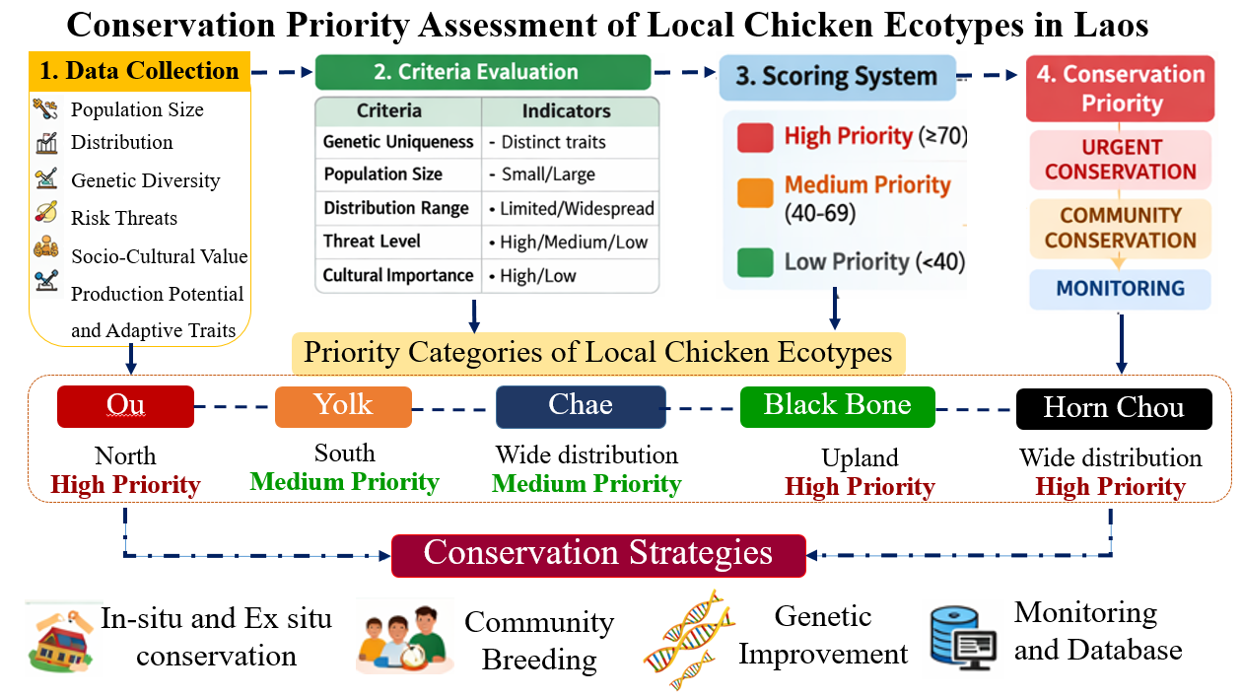
Figure 9. Conservation priority assessment of local chicken ecotypes in Lao PDR.

Climate Risks Affecting Local Chickens in Lao PDR
Local chickens in Lao PDR are mainly raised under low-input scavenging systems, where they are highly exposed to environmental and climate-related stressors. These climate risks have both direct and indirect impacts on productivity, survival, and the sustainability of genetic resources. The most important risks include heat stress, increased disease pressure, and seasonal feed shortages, which directly affect productivity, reproduction, and survival (Hoffmann, 2010; Lara and Rostagno, 2013). Indirect effects refer to the secondary consequences of climate stress that influence production systems, breeding efficiency, and long-term genetic improvement. Climate-induced feed scarcity, caused by drought and seasonal variation, reduces the availability of scavenged feed resources, leading to poor nutrition, slower growth, delayed sexual maturity, and reduced reproductive performance (FAO, 2015). Climate change also affects animal health both directly and indirectly (Lacetera, 2019; Husen et al., 2022). Furthermore, increased disease outbreaks and mortality reduce flock size and selection intensity, thereby limiting opportunities for effective genetic improvement. Climate change may also result in the loss of valuable local genetic resources, reducing genetic diversity and adaptive potential (Hoffmann, 2010). The impacts of climate change on local chickens are summarized in Table 6.
In addition, climate change contributes to increased disease pressure by promoting the survival and transmission of pathogens and parasites. Newcastle disease, in particular, remains one of the most important constraints affecting village chicken production in Lao PDR (Alders and Pym, 2009). These climate risks not only reduce current performance but also limit long-term genetic improvement by increasing mortality and reducing reproductive efficiency. Therefore, understanding these risks is essential for developing climate-smart breeding programs that enhance heat tolerance, disease resistance, and the overall adaptability of local chicken populations.
Table 6. Climate change impacts on Local Chickens.
Typology | Short description of the impact | Major influential factors | References
Direct | - Reduced productivity (egg/meat yield)  - Decreased reproductive performance  - Negatively affected immune function  - Increased mortality | Heat stress (high temperature), increased disease pressure (Newcastle disease, parasites) | Hoffmann, 2010; Lara and Rostagno, 2013; Alders and Pym, 2009
Indirect | - Reduced feed availability due to drought and seasonal variation  - Poor nutrition, slower growth, delayed sexual maturity  - Reduced reproductive performance  - Loss of genetic diversity and adaptive potential  - Reduced flock size and selection intensity | Drought, seasonal variation, climate-induced feed scarcity, increased temperature and precipitation variability, extreme weather events | FAO, 2015; Hoffmann, 2010; Lacetera, 2019; Husen et al., 2022

Climate-Smart Selection Index
A climate-smart selection index was developed to support balanced genetic improvement of productivity, adaptation, and resilience traits in local chickens raised under climate-vulnerable, low-input production systems in Lao PDR. The breeding objectives integrate economically important traits (body weight, egg production) with adaptive traits (heat tolerance, survival rate) and resilience traits (disease resistance, feed efficiency), ensuring that selection contributes both to productivity and long-term flock sustainability (FAO, 2010). The inclusion of adaptive and resilience traits in the aggregate breeding objective reduces the risk of unfavorable correlated responses and enhances population stability under climate stress (Falconer & Mackay, 1996; Hoffmann, 2010). By maximizing the correlation between the selection index and the climate-responsive breeding objective, the program ensures sustainable and context-specific genetic improvement.
In additional, selection criteria were based on moderate heritability, favorable genetic correlations, and the feasibility of measurement under field conditions. Body weight at 12 weeks (BW12) was included due to its relatively high heritability and strong association with later growth and egg traits. Age at first egg (AFE) was used as an indicator of reproductive efficiency because of its moderate heritability and negative genetic correlation with egg number. Survival to 12 weeks (SURV) was incorporated as a resilience trait reflecting disease resistance and environmental fitness. The development of a Climate-Smart Selection Index for improving productivity and resilience in local chickens is illustrated in Figure 10.
The selection index was constructed following classical selection index theory:
I = b₁​EBV_{BW12}​+b₂​EBV_{AFE}​+b₃​EBV_{SURV}
Where b_{i} represent economic and climate-adjusted weights derived from genetic and phenotypic (co) variance matrices. This approach maximizes the correlation between the index and the aggregate breeding objective, enabling sustainable and climate-responsive genetic gain in village local chicken systems.
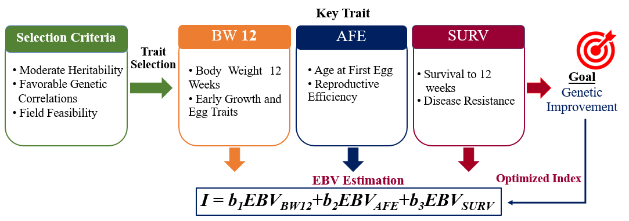
Figure 10. Climate-Smart Selection Index for improving productivity and resilience in local chickens in Lao PDR.
Breeding system
National Climate-Smart Local Chicken Breeding Program for Lao PDR
The National Climate-Smart Local Chicken Breeding Program in Lao PDR is structured as a three-tier pyramidal system consisting of nucleus, multiplier, and village production levels. The program follows a within-breed selection strategy to enhance genetic merit while maintaining local adaptation and genetic identity. The overall structure of the breeding program is presented in Figure 11.
At the base level, village production flocks operate under low-input scavenging systems and provide phenotypic performance data, including growth, egg production, and survival. These data form the foundation for genetic evaluation. Selected birds are transferred to the multiplier or nucleus level for further breeding. The intermediate multiplier units are responsible for multiplying improved breeding stock and disseminating genetically superior birds back to village farmers. This structure increases selection intensity at the nucleus level while ensuring wide dissemination of genetic progress. At the central level, the nucleus flock conducts systematic genetic evaluation and applies a climate-smart selection index integrating productivity and adaptive traits. This hierarchical breeding structure is consistent with conventional livestock breeding program design, where genetic gain is generated at the nucleus level and disseminated downward (Introduction to Quantitative Genetics). The incorporation of adaptive traits such as heat tolerance and disease resistance aligns with climate-smart livestock breeding principles proposed by Food and Agriculture Organization of the United Nations (2013), which emphasize resilience under climate variability. Furthermore, maintaining within-breed selection supports long-term population stability and reduces genetic dilution associated with indiscriminate crossbreeding (Gicquel et al., 2020). Overall, the pyramidal structure ensures sustainable genetic improvement, preservation of Lao indigenous genetic resources, and enhanced climate resilience in village poultry production systems.
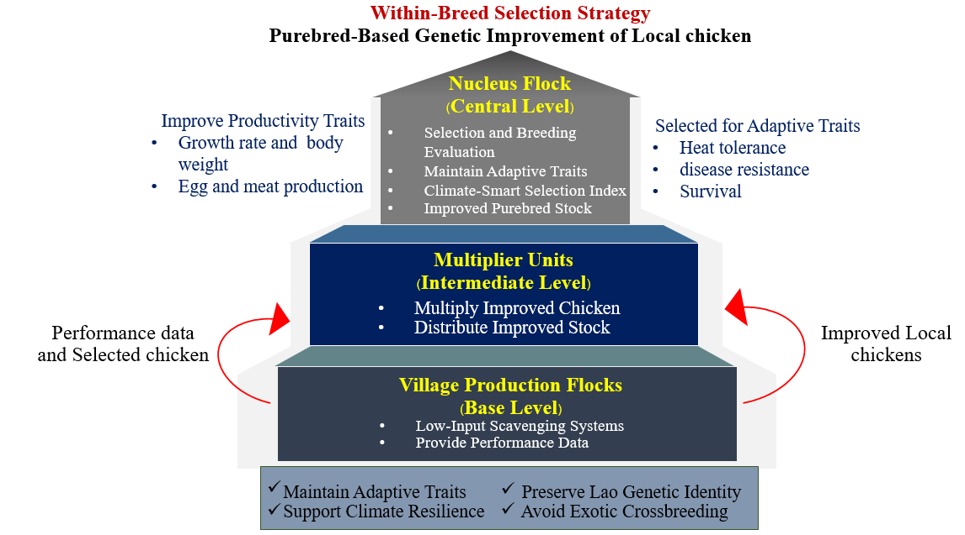
Figure 11. Structure of the National Climate-Smart Local Chicken Breeding Program in Lao PDR based on a within-breed pyramidal selection system. Genetic improvement is generated at the nucleus level and disseminated through multiplier units to village production flocks, while performance data flow upward for genetic evaluation.
Expected Timeline for Genetic Improvement in National Climate-Smart Local Chicken Breeding Program in Lao PDR
The implementation of a national climate-smart breeding program for indigenous chickens in Lao PDR is expected to follow a phased approach over approximately ten years. This strategy allows for the gradual development of breeding infrastructure, systematic selection, and the eventual dissemination of improved genetic resources to farmers while maintaining the adaptive traits of local chicken populations. The overall framework and timeline of the breeding program are illustrated in Figure 12.
- Phase 1: System Setup (1–2 Years)
The initial phase focuses on establishing the basic infrastructure required for the breeding program. This includes the establishment of nucleus flocks of local chickens that will serve as the core population for selection and genetic evaluation. During this stage, a standardized performance recording system will be developed to collect baseline data on important production and adaptation traits, such as survival, growth, and egg production. A selection index will also be developed to identify superior breeding candidates based on productivity, resilience, and adaptation to local environmental conditions. In addition, training activities will be conducted to strengthen farmers’ capacity in flock management and data recording. The main outcome of this phase will be the availability of baseline data and a functional recording system to support future genetic evaluation.
- Phase 2: Genetic Improvement and Evaluation (3–5 Years)
The second phase focuses on the implementation of systematic selection and monitoring of genetic progress. Using the performance data collected during the first phase, superior birds will be selected as breeding candidates based on the established selection criteria. Continuous recording and evaluation will allow researchers to monitor improvements in key productivity traits. During this stage, early genetic improvement is expected to become visible through phenotypic gains, including improved growth performance, egg production, and survival rates.
- Phase 3: Nationwide Impact (6–10 Years)
The final phase aims to expand the impact of the breeding program at the national level. Improved local chicken lines developed through the selection process will be distributed to farmers across different regions of Lao PDR. This dissemination will help increase productivity and resilience of local chicken populations while maintaining their adaptability to local environments. In the long term, the program is expected to generate sustainable genetic gain, improve farmer livelihoods, and contribute to national food security.
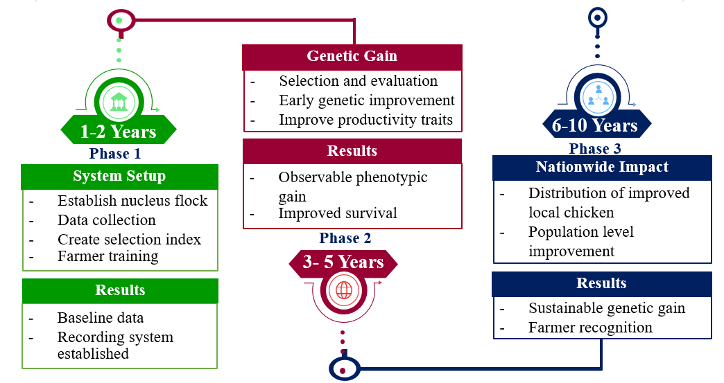
Figure 12. Implementation framework of the climate-smart breeding program for local chickens in Lao PDR
National Breeding Strategy
The National Climate-Smart Local Chicken Breeding Program for Lao PDR is a proposed breeding strategy designed to achieve sustainable genetic improvement in local chicken populations while maintaining both genetic diversity and environmental adaptability. The strategy prioritizes within-breed selection as the primary pathway for long-term genetic gain, while permitting structured crossbreeding under strict genetic control where appropriate.
Genetic improvement will be achieved through systematic estimation of breeding values (EBVs) using quantitative genetic models such as Best Linear Unbiased Prediction (BLUP) and genomic selection approaches. These methods enable accurate identification of superior breeding candidates based on additive genetic merit (Meuwissen et al., 2001; Ibtisham et al., 2017). The strategy integrates climate resilience into selection objectives, emphasizing traits such as survival rate, disease resistance, and adaptability to scavenging systems, growth performance, and reproductive efficiency. Because additive genetic variance determines long-term response to selection, it remains the primary focus of the breeding program.
Moreover, structured crossbreeding may be implemented to exploit heterosis, but only within a controlled framework that maintains purebred nucleus populations and prevents indiscriminate genetic dilution (Hill, 2014). Conservation safeguards are therefore embedded within the national strategy to balance genetic gain with sustainability.

Breeding structure
The breeding structure of the National Climate-Smart Local Chicken Breeding Program for Lao PDR is designed as a hierarchical, multi-tier system to achieve sustainable genetic improvement while maintaining indigenous genetic diversity. The system consists of three main tiers: (1) Nucleus tier, responsible for performance recording, pedigree management, and genetic evaluation; (2) Multiplier tier, for controlled dissemination of improved stock; and (3) Village production tier, where selected birds are distributed to smallholders under supervised breeding plans.
Genetic evaluation within the nucleus flock is conducted using a combination of Best Linear Unbiased Prediction (BLUP), genomic selection (GS), and whole-genome approaches, which integrate both phenotypic and genomic information to optimize estimated breeding values (EBVs) and maximize selection response (Meuwissen et al., 2001). Improvement pathways include purebred local selection, structured crossbreeding with adapted exotics, and ecotype-specific lines adapted to lowland, upland, and highland production systems. Crossbreeding strategies have been shown to improve growth performance and exploit heterosis when designed properly to preserve the adaptive traits of local chickens (Mancinelli et al., 2023; Berghof et al., 2024). Mating strategies are controlled to minimize inbreeding, maintain effective population size, and safeguard rare alleles, ensuring long-term conservation of Local chickens (Sørensen, 2010; https://www.fao.org/4/t0559e/t0559e04.htm?utm_ source=chatgpt.com). This structured framework ensures cumulative genetic gain, preservation of locally adapted traits, and controlled dissemination of improved birds to rural communities.

Decide Improvement Pathway
The improvement pathway for a national local chicken breeding program must reflect the production conditions, breeding goals, farmers’ preferences, and the genetic resources available in the country. In this program, improvement begins with the local breeds commonly preferred by farmers and aims to establish a reference flock representing the major ecotypes of local chickens. Within this flock, pedigree information and performance records such as growth rate, reproductive performance, survival, and feed efficiency are collected to evaluate the genetic potential of the population (Falconer, 1996; Wolc et al., 2011). These information provide the basis for evaluating the genetic potential of the population and for guiding selection aimed at improving productivity while maintaining the adaptive characteristics of local chickens. The improvement pathway for a national local chicken breeding program is shown in Figure 13.
Based on performance evaluation and farmers’ and consumers’ preferences, one ecotype is selected as the foundation population (Generation 0). Selection is then applied within the breed, focusing on key traits including growth performance, feed efficiency, reproduction, survival, heat tolerance, and disease resistance. Male chickens are primarily selected for growth and body weight performance, while female chickens are selected for egg production, adaptability, survival, and disease resistance. The selected birds are mated to produce the next generation (Generation 1). Offspring performance is evaluated, the best individuals are selected, and inferior animals are culled. This selection cycle is repeated across generations, with continuous evaluation and selection, leading to gradual genetic improvement while maintaining the adaptive traits of local chicken populations.
In addition, structured crossbreeding may be considered as a complementary strategy to exploit heterosis and improve productivity when appropriate. However, crossbreeding should be implemented under controlled breeding management to ensure the conservation of pure indigenous lines and to prevent the dilution of valuable local genetic resources (FAO, 2013). Developing selection lines that reflect local ecotypes is another practical approach for improving local chickens. Populations that are already adapted to particular environmental conditions can be improved through targeted selection within those ecotypes. This enhances productivity in specific production environments while preserving the natural resilience of local chickens to climatic stress and other local challenges (Besbes, 2009). Overall, these improvement pathways provide a flexible framework that balances productivity improvement with the conservation of local genetic resources and long-term sustainability.
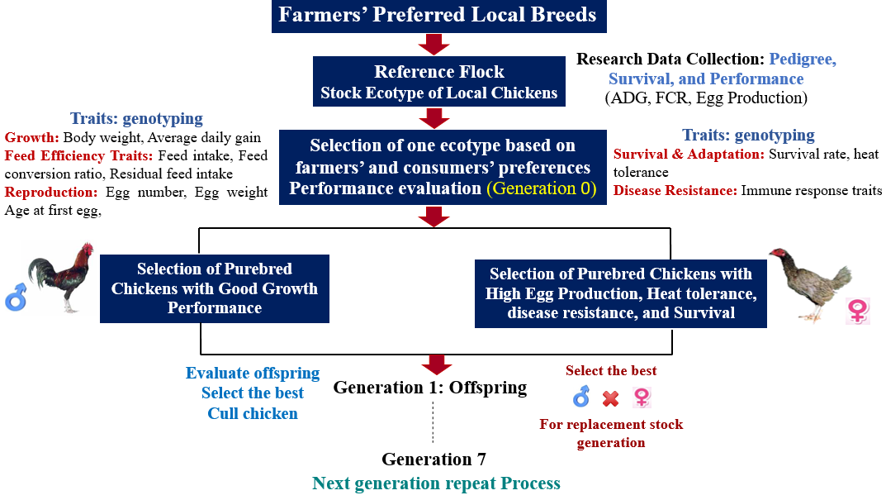
Figure 13. Improvement pathway for a national local chicken breeding program, illustrating selection, evaluation, and generation progression.
Selection Response by Mating Strategy
In this local chicken breeding program, genetic improvement is achieved through carefully structured within-breed selection and planned mating. Males and females with superior performance in traits such as growth rate, egg production, feed efficiency, survivability, and disease resistance are identified and paired strategically. The offspring are subsequently evaluated, with top-performing individuals retained as replacement stock and less competitive birds removed from the breeding population. By consistently applying this cycle across successive generations, both production and adaptive traits are enhanced while inbreeding is controlled. This approach ensures a steady, long-term increase in genetic merit, preserving the resilience and unique characteristics of the local chicken population (Ngeno, 2015; Miyumo et al., 2024). Ultimately, this strategy supports the sustainable development of a locally adapted and productive chicken flock.
Expected outputs
The breeding program will produce clearly defined breeding objectives and selection criteria for climate-resilient and productive traits. It will develop a national breeding strategy with an implementation plan, establish a trait recording and evaluation system, provide capacity building support for farmers with emphasis on women and youth participation, and create conservation guidelines for local chicken ecotypes.
Expected outcome
The local chickens are expected to show improved climate resilience, productivity, and survival, leading to increased egg and meat production. The program will also enhance income and food security for smallholder farmers and ensure the preservation of local genetic diversity for long-term sustainability.
Expected Impacts
The climate-smart local chicken breeding program will improve adaptation and productivity, reducing mortality and stabilizing egg and meat production under climate stress. Enhancing key traits such as heat tolerance, disease resistance, and feed efficiency will strengthen the overall performance of local chickens. These gains are expected to increase income and food security for smallholder farmers, particularly benefiting women and youth through inclusive participation. In the long term, the program will support sustainable, climate-resilient livelihoods and preserve the genetic diversity of local chicken populations.
Conclusion
Local chickens remain an integral component of rural livelihoods, food security, and cultural practices in Lao PDR. However, their production potential is constrained by traditional management systems, the absence of systematic performance recording, and limited genetic improvement. At the same time, increasing climate variability poses additional challenges for village-based poultry systems. The findings of this study highlight the substantial phenotypic and genetic diversity present within Local chicken populations, indicating strong potential for sustainable genetic improvement while maintaining valuable adaptive traits. In response, this report proposes a climate-smart breeding framework that integrates productivity and resilience traits within a structured breeding system linking nucleus, multiplier, and village production levels. By combining genetic improvement with conservation of indigenous resources, the proposed approach provides a practical pathway to enhance productivity, strengthen resilience to environmental stress, and support sustainable poultry development and rural livelihoods in Lao PDR.

Recommendation
To support the effective implementation of a national climate-smart breeding program for local chickens in Lao PDR, several key actions are recommended. First, a national performance recording and data management system should be established to collect reliable information on important production and resilience traits, including growth, egg production, survival, and disease incidence. Second, further research should strengthen the genetic characterization of local chickens through genomic and phenotypic studies to better understand genetic diversity and adaptive traits across different agro-ecological zones. Third, a structured breeding program based on a pyramidal system linking nucleus, multiplier, and village production levels should be implemented to generate sustainable genetic improvement while ensuring the dissemination of improved birds to smallholder farmers. In addition, conservation strategies should be developed to protect local chicken genetic resources through both in situ and ex situ approaches. Breeding objectives should also incorporate climate resilience traits such as heat tolerance, disease resistance, and survival ability. Finally, strengthening farmer participation, veterinary services, and institutional coordination will be essential to ensure the long-term sustainability of the national breeding program.

Acknowledgement
The development of this breeding program was supported by the Africa–Asia Biosciences Challenge Fund (AABCF), a capacity-strengthening initiative jointly implemented by the International Livestock Research Institute (ILRI), the University of Queensland (UQ), and the University of Melbourne (UoM), with support from the Australian Centre for International Agricultural Research (ACIAR). The authors gratefully acknowledge the Centre for Tropical Livestock Genetics and Health (CTLGH) at ILRI for technical support and assistance. The first author also sincerely thanks the National Agriculture and Forestry Research Institute (NAFRI), Lao P.D.R., for their support and for providing the opportunity to participate in this fellowship program.

References
Alders, R. (2004). Village poultry in northern Lao PDR. Participatory Livestock Development
Project sponsored by CIAT and ILRI (No. 5, p. 55). Working Paper.
Alders, R. G., & Pym, R. A. E. (2009). Village poultry: still important to millions, eight thousand years after domestication. World's Poultry Science Journal, 65(2), 181-190.
Bouahom, B., Keonouchanh, S., & Khamphavong, S. (2007). Indigenous chickens: an important part of rural livelihoods in the Lao People's Democratic Republic. People and animals, traditional livestock keepers: guardians of domestic animal diversity, 71-77.
Burgos, S., Otte, J., & Roland-Holst, D. (2008). Poultry, HPAI and Livelihoods in Lao People’s
Democratic Republic–A Review.
Besbes, B. (2009). Genotype evaluation and breeding of poultry for performance under sub-optimal village conditions. World's Poultry Science Journal, 65(2), 260-271.
Birhanu, M. Y., Alemayehu, T., Bruno, J. E., Kebede, F. G., Sonaiya, E. B., Goromela, E. H., & Dessie, T. (2021). Technical efficiency of traditional village chicken production in Africa: Entry points for sustainable transformation and improved livelihood. Sustainability, 13(15), 8539.
Berghof, T. V., Bedere, N., Peeters, K., Poppe, M., Visscher, J., & Mulder, H. A. (2024). The genetics of resilience and its relationships with egg production traits and antibody traits in chickens. Genetics Selection Evolution, 56(1), 20.
Dana, N., Van der Waaij, L. H., Dessie, T., & van Arendonk, J. A. (2010). Production objectives and trait preferences of village poultry producers of Ethiopia: implications for designing breeding schemes utilizing indigenous chicken genetic resources. Tropical animal health and production, 42(7), 1519-1529.
Falconer, D. S. (1996). Introduction to quantitative genetics. Pearson Education India.
FAO. (2010). Breeding strategies for sustainable management of animal genetic resources. FAO.
FAO. 2012. Phenotypic characterization of animal genetic resources. FAO Animal Production and Health Guidelines No. 11. Rome.

FAO. (2013). Climate-smart Agriculture: Sourcebook, https://openknowledge. fao.org/

server/api/core/bitstreams/b21f2087-f398-4718-8461-b92afc82e617/content
FAO. (2013). In vivo conservation of animal genetic resources. FAO animal production and health guidelines.
FAO. (2014). Decision Tools for Family Poultry Development. Food and Agriculture Organization of the United Nations, Rome, Italy.
FAO. (2014). Family Poultry Development-Issues, Opportunities and Constraints. Animal Production and Health Working Paper. No. 12.
FAO. (2015). The Second Report on the State of the World’s Animal Genetic Resources for Food and Agriculture. FAO, Rome, Italy.
FAO. (2019). The State of the World’s Biodiversity for Food and Agriculture. FAO, Rome.
Guèye, E. F. (2000). The role of family poultry in poverty alleviation, food security and the promotion of gender equality in rural Africa. Outlook on agriculture, 29(2), 129-136.
Gicquel, E., Boettcher, P., Besbes, B., Furre, S., Fernández, J., Danchin-Burge, C., & Leroy, G. (2020). Impact of conservation measures on demography and genetic variability of livestock breeds. Animal, 14(4), 670-680.
Hoffmann, I. (2010). Climate change and the characterization, breeding and conservation of animal genetic resources. Animal genetics, 41, 32-46.
Hill, W. G. (2014). Applications of population genetics to animal breeding, from Wright, Fisher and Lush to genomic prediction. Genetics, 196(1), 1-16.
Husen, M., Yusuf Bekere, H., & Hussen, D. H. (2022). Review on impact of climate change on livestock health and productivity. Husen Harun MS, Bekere H, Hussen DH, Yusuf MA. Review on impact of climate change on live stock health and productivity. BAOJ Nutri, 1(1), 1001.
Hutu, I., & Oldenbroek, K. (2025). Animal Breeding Program. In Theriogenology-Recent Advances in the Field. IntechOpen.
Ibtisham, F., Zhang, L., Xiao, M., An, L., Ramzan, M. B., Nawab, A., & Xu, Y. (2017). Genomic selection and its application in animal breeding. The Thai Journal of Veterinary Medicine, 47(3), 301-310.
Kawabe, K., Worawut, R., Taura, S., Shimogiri, T., Nishida, T., & Okamoto, S. (2014). Genetic diversity of mtDNA D-loop polymorphisms in Laotian native fowl populations. Asian-Australasian journal of animal sciences, 27(1), 19.
Khoutsavang, P. (2024). Investigation of genetic diversity in native chicken of the Lao People’s Democratic Republic (Lao PDR) (Doctoral dissertation, Suranaree University of Technology).
Lara, L. J., & Rostagno, M. H. (2013). Impact of heat stress on poultry production. Animals, 3(2), 356-369.
Livestock Research Center (LRC). 2014. Study on livestock production and management in Lao PDR. National Agriculture and Forestry Research Institute (NAFRI), Vientiane Capital, Lao PDR. Book
Lacetera, N. (2019). Impact of climate change on animal health and welfare. Animal Frontiers, 9(1), 26-31.
Lao PDR. (2021). The 9th National Socio-Economic Development Plan (2021–2025). Vientiane: Government of Lao PDR
Lormaisim, S., Dizon, J. T., Sidthisone, C., Koulavong, B., & Tounmanysone, T. (2023). Roles of women in livestock raising in Lao PDR. International Journal of Advanced Research and Publications, 6(1), 17–?. ISSN: 2456-9992.
Meuwissen, T. H., Hayes, B. J., & Goddard, M. (2001). Prediction of total genetic value using genome-wide dense marker maps. genetics, 157(4), 1819-1829.
Ministry of Natural Resources and Environment (MONRE). (2010). National Strategy on Climate Change of Lao PDR. Vientiane: MONRE.
Mwacharo, J. M., O. Hanotte, H. Jianlin, and H. H. Jianlin. 2013. Indigenous chicken production systems and their contribution to livelihoods in developing countries. World’s Poultry Science Journal 69: 1–18.
Melesse, A. (2014). Significance of scavenging chicken production in the rural communityof Africa for enhanced food security. World's Poultry Science Journal, 70(3), 593-606.
Maw, A. A., Kawabe, K., Shimogiri, T., Rerkamnuaychoke, W., Kawamoto, Y., Masuda, S., & Okamoto, S. (2015). Genetic diversity and population structure in native chicken populations from Myanmar, Thailand and Laos by using 102 indels markers. Asian-Australasian Journal of Animal Sciences, 28(1), 14.
Ministry of Agriculture and Forestry (MAF). (2015). Agriculture Development Strategy to 2025 and Vision to 2030. Vientiane: MAF.
Ministry of Natural Resources and Environment (MONRE). (2016). National Biodiversity Strategy and Action Plan of Lao PDR. Vientiane: MONRE.
Ministry of Agriculture and Forestry. 2017. National Strategy and Plan of Action for Animal Genetic Resources in Lao PDR.
Ministry of Natural Resources and Environment (MONRE). (2020). Nationally Determined Contribution (Updated NDC) of Lao PDR. Vientiane: MONRE.
Macharia, J. K., Ogolah, E. O., & Munyaneza, J. P. (2022). Indigenous chicken farming in Kenya: a minireview of genetic resource, production systems, constraints, and opportunities. Journal of Intellectual Property, 6(4), 183-193.
Mancinelli, A. C., Menchetti, L., Birolo, M., Bittante, G., Chiattelli, D., & Castellini, C. (2023). Crossbreeding to improve local chicken breeds: Predicting growth performance of the crosses using the Gompertz model and estimated heterosis. Poultry Science, 102(8), 102783.
Muttaqin, Z., Sartika, T., & Saputra, F. (2023). Genetic diversity of Gallus sp. in Southeast Asia based on d-lopp: In silico study. Journal of Advanced Veterinary and Animal Research, 10(4), 817.
Miyumo, S., Wasike, C. B., Ilatsia, E. D., Bennewitz, J., & Chagunda, M. G. (2024). Evaluation of selection strategies in dual-purpose and specialized breeding of indigenous chicken. Poultry Science, 103(8), 103916.
Ngeno, K. (2015). Breeding program for indigenous chicken in Kenya. (PhD thesis). Wageningen University.
Phommasack, O. (2014). A survey of commercial small-scale poultry production systems and nutrient characterisation of local feed ingredients in Laos: a thesis presented in partial fulfilment of the requirements for the degree of Master of AgriScience at Massey University (Doctoral dissertation, Massey University).
Project Collaboration between Thailand and Lao PDR for the Conservation and Development of indigenous Chickens in the Lao PDR (2020). https://digital.library.tu.ac.th/tu_dc/frontend/Info /item/dc:173407
Roh, H. J., Kim, S. C., Cho, C. Y., Lee, J., Jeon, D., Kim, D. K., & Manikku, L. (2020). Estimating genetic diversity and population structure of 22 chicken breeds in Asia using microsatellite markers. Asian-Australasian journal of animal sciences, 33(12), 1896.
Sørensen, P. (2010). Chicken genetic resources used in smallholder production systems and opportunities for their development.
Wilson R.T. 2008. Numbers, Ownership, Production and Diseases of Poultry in the Lao People's Democratic Republic. World's Poultry Science Journal.
Wolc, A., Stricker, C., Arango, J., Settar, P., Fulton, J. E., O'Sullivan, N. P., & Dekkers, J. C. (2011). Breeding value prediction for production traits in layer chickens using pedigree or genomic relationships in a reduced animal model. Genetics Selection Evolution, 43(1), 5.
Wong, J. T., de Bruyn, J., Bagnol, B., Grieve, H., Li, M., Pym, R., & Alders, R. G. (2017). Small-scale poultry and food security in resource-poor settings: A review. Global Food Security, 15, 43-52.
https://www.developmentaid.org/donors/view/143781/ministry-of-agriculture-and-forestry-of-laos.
http://www.un.org/ sustainabledevelopment/sustainable-development-goals/, January 15, 2017
https://www.fao.org/4/t0559e/t0559e04.htm?utm_source=chatgpt.com
https://digital.library.tu.ac.th/tu_dc/frontend/Info /item/dc:173407

